

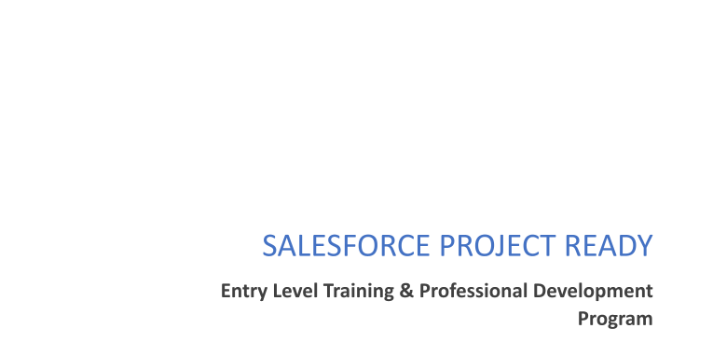

**Project Title: Online Training Management**

# Day 1 :

Topic: Create your DF Developer account to get Started

Milestone / Activities: Account Creation

Detailed Description: Account Creation from developer.salesforce.com

Upload the Screenshot the Milestone / Activities :-

# Day 2 :

Topic: App & Custom Object Creation , Field Creation

Milestone / Activities: Create 5 Custom Object and its fields

Detailed Description: Course, Trainer, Batch , Meeting, Student

Upload the Screenshot the Milestone / Activities :

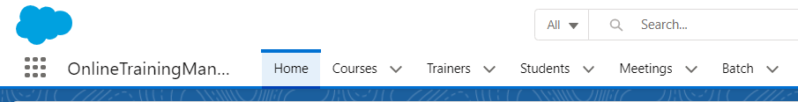

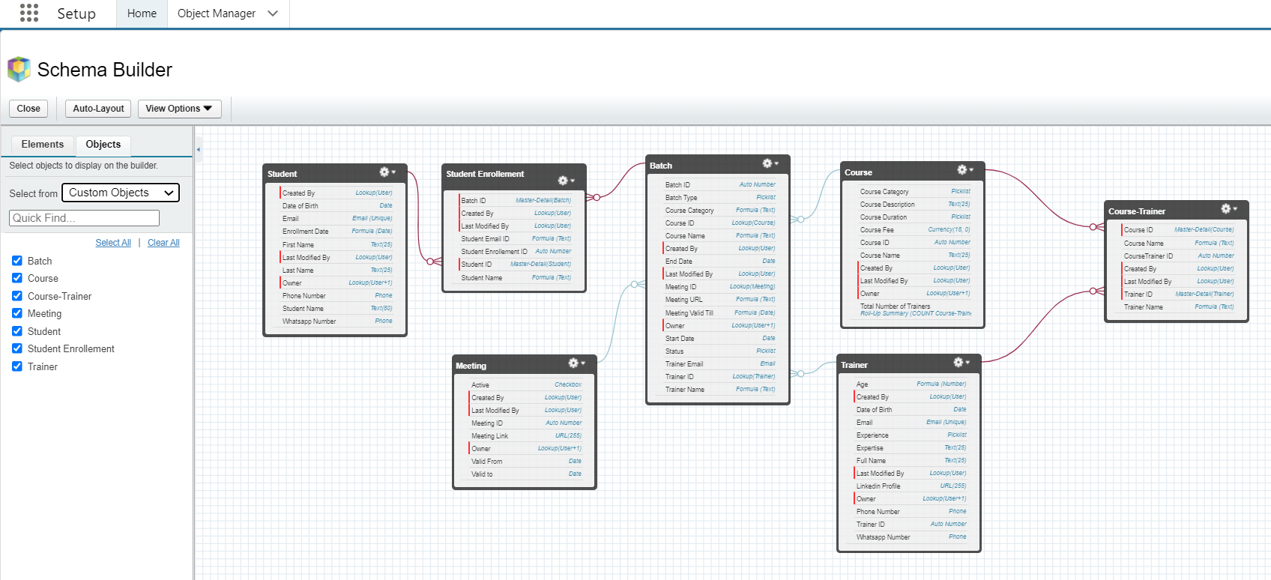

# Day 3 :

Topic: Validation Rule on custom Object , Relationships(Master Detail, Look-Up)

Milestone / Activities: Validation Rule on custom Object(Course, Trainer, Meeting, Student)

Detailed Description:

Upload the Screenshot the Milestone / Activities :



# Day 4 :

Topic: Automation on Custom Objects

Milestone / Activities: Automation Rule on Custom Object (Course,Meeting,Batch)

Detailed Description:

Upload the Screenshot the Milestone / Activities :

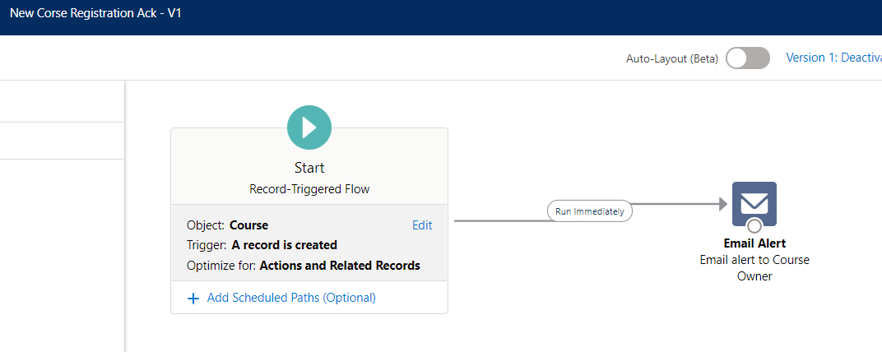

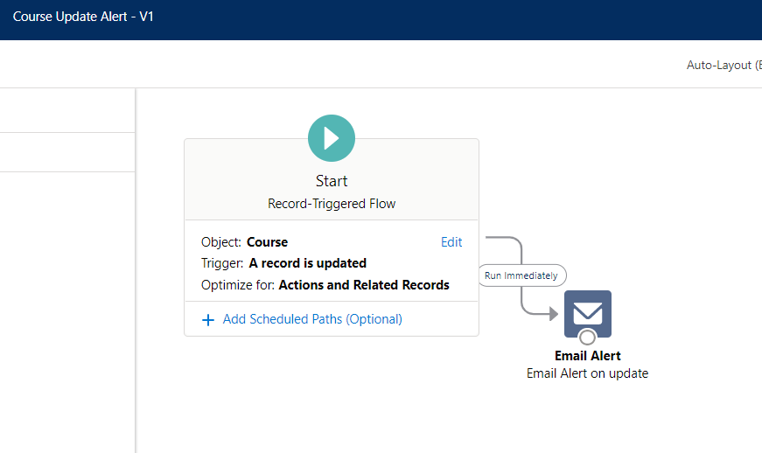

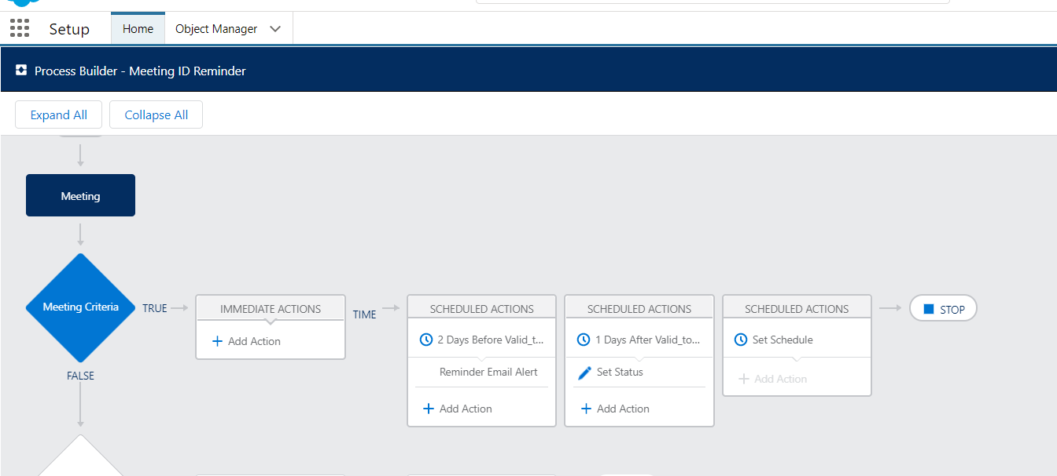

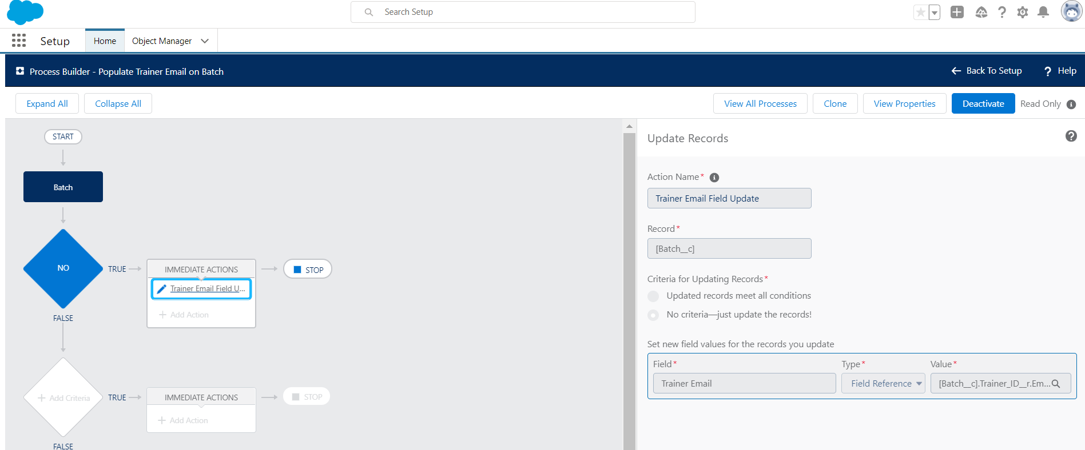 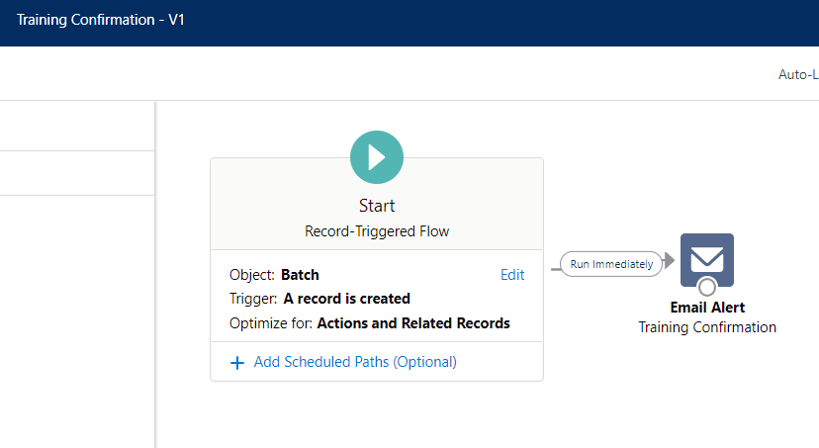

# Day 5 :

Topic: VF Pages (Custom Pages)

Milestone / Activities: VF Pages (Custom Pages)- Standard Controller , Custom Controller

Detailed Description: Custom Pages of Course, Trainer, Batch , Meeting, Student Object

Upload the Screenshot the Milestone / Activities :

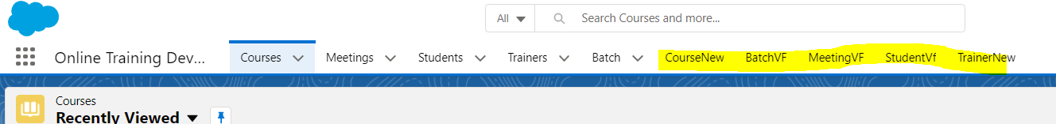

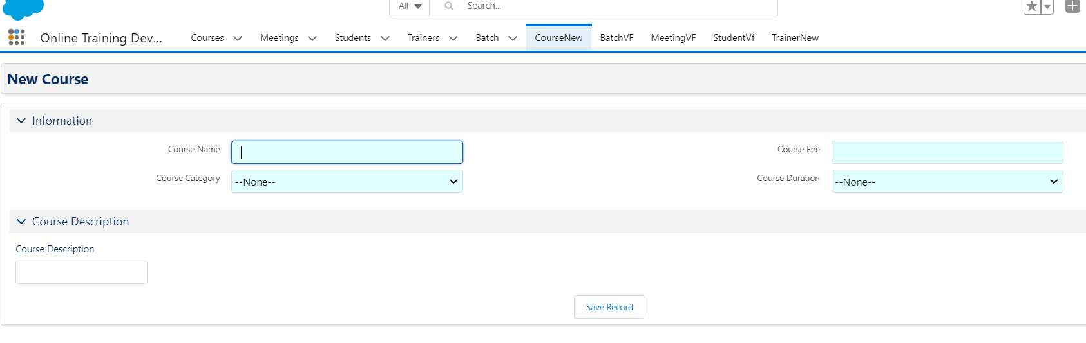

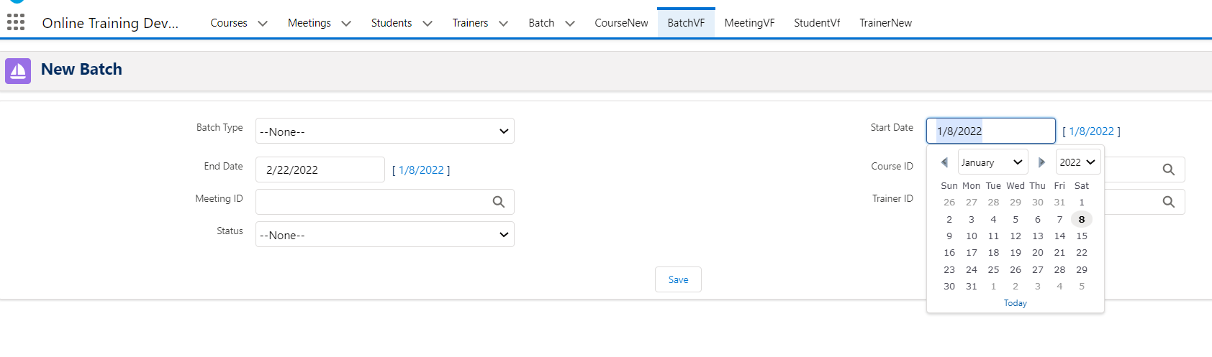

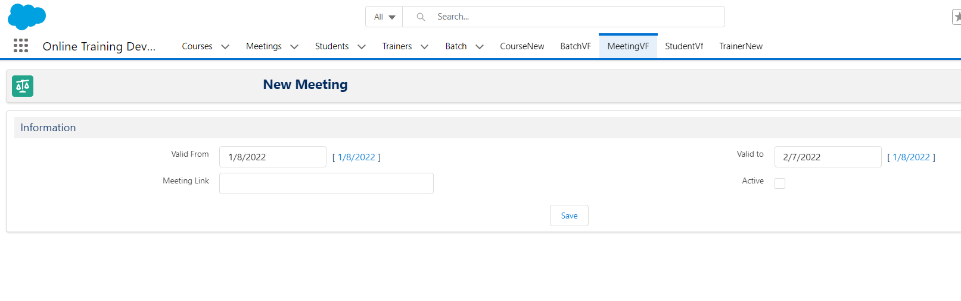

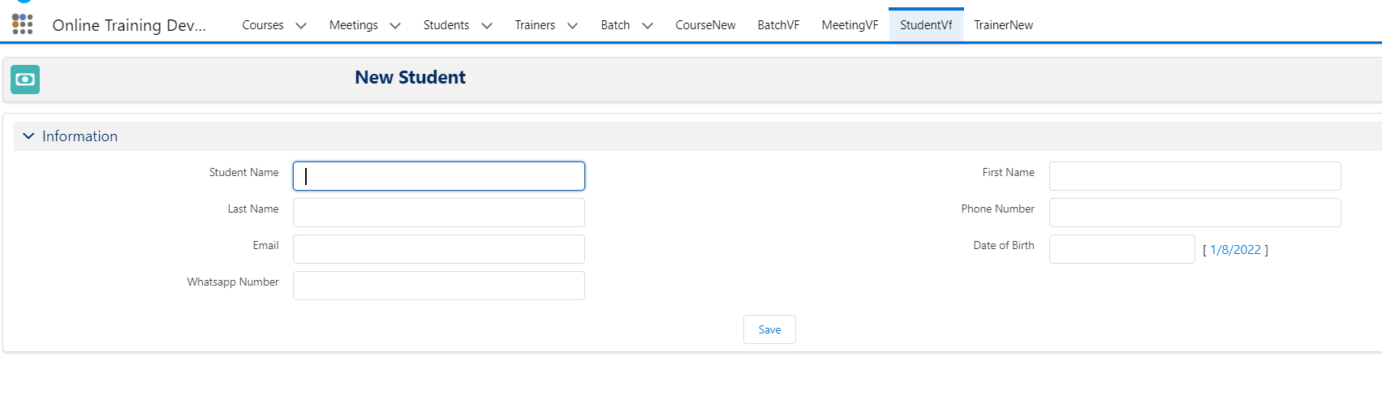

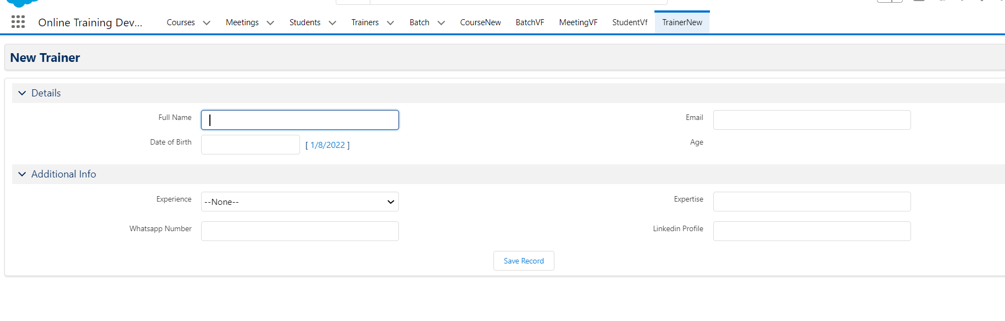

# Day 6 :

Topic: VF Pages (Custom Pages)

Milestone / Activities:

Detailed Description:

Upload the Screenshot the Milestone / Activities :